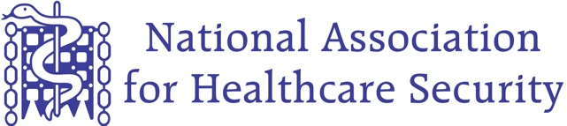
NAHS 2020 Awards Nomination
Category | Healthcare Security Manager / ASMS (LSMS)
Section A – Individual details
Nominee
Organisation
Nominators Name
Nominators Position
Connection
This award category is for the Healthcare Security Manager / ASMS (LSMS) who consistently demonstrates their professionalism, dedication and willingness to address the needs of the Trust / organisation. In addition, the nominee is expected to take all necessary and appropriate action in ensuring the safety and security of staff and patients alike and lead by example ensuring that their team delivers an outstanding service. Please provide detailed evidence of any significant events or incidents to support your nomination. Please ensure that all information and evidence is suitably redacted to ensure patient confidentiality is protected. All nominations and supporting evidence should be emailed to info@nahs.org.uk
Section B – Details of Nomination
- Consistently leads by example and inspires their team to deliver outstanding service for Patients, Staff and Visitors
- Always considers the patient’s care needs alongside their Trust / Employers needs
- Consistently promotes excellence and strives to improve the safety and security of the Trust / organisation and ‘goes the extra mile’ to keep staff, patients, visitors and assets safe.
- Actively demonstrates their integrity in accordance with their respective Trust’s values and behaviours along with ensuring that the Security department / team also work to the highest standards expected.
- A manager who, by their actions and dedication clearly deserves National recognition.
- Additional information to support the nomination.

